PROJECT FILE
PRACTICAL FILE
BASED ON
COMPUTER FUNDAMENTAL
BCA (DATA SCIENCE)

SUBMITTED TO UNIVERSITY OF JAMMU, BHADERWAH CAMPUS FOR THE PARTIAL FULFILLMENT OF THE AWARD OF BCA-1ST SEMESTER

SUBMITTED TO
CHANDERDEEP SIR SUBMITTED BY
ATIF BASHIR
DEPT. OF CS & IT ROLL NO. 113040020

UNIVERSITY OF JAMMU, BHADERWAH CAMPUS

Acknowledgement

I would like to express my sincere gratitude for the support and guidance that helped me complete this practical file.

First of all, I want to thank Chanderdeep Sir, our Computer Fundamentals teacher, for his patient guidance and consistent support. His knowledge and motivation have greatly strengthened my understanding of MS Office and made this practical file a valuable learning experience.

I also acknowledge my own effort in completing this work. This project challenged me in many ways but also helped me improve my MS Office skills and build confidence.

Although this practical file is mainly based on my individual work, I appreciate the learning environment around me. The exchange of ideas and the supportive atmosphere have influenced my approach throughout this task.

In the end, I am thankful to Chanderdeep Sir and the learning community for their encouragement and inspiration. This practical file reflects the hard work, dedication, and commitment I, Atif, have put into learning and improving my skills.

Thank you.

CERTIFICATE
This is to certify that Mr.Atif Bashir a student enrolled in the BCA 1st semester at the University of Jammu, Bhaderwah Campus, has successfully completed the Practical File during the session. This accomplishment contributes towards the partial fulfillment of credits for the "Computer fundamental" practical course.

Mr. Atif Bashir has submitted a satisfactory report, as compiled in the following pages, under my diligent supervision.

Total number of practical certified are: 20.

Internal Examiner Head of the Department
Signature Signature

External Examiner Principal
Signature Signature
INDEX
s.no. | Program
1 | . Select your document using select all option and change the font size of your document underline the word using underline option, draw a line through the middle of the selected text using stripe through option . Create a small no. below the text base line of the word using subscript create a small number above the text based line using superscript
2 | . Insert a picture in a fixed place than take the picture into the center of the page .add the thick boader around and craps the picture size is 0.5 inch from the left side change the size of the picture by prassing right click on the mouse and the picture insert caption to the picture.
3 | . Insert header and footer using the header and footer option. Draw a text box and insert the following text …. Insert excel worksheet using object option in the insert menu. Create a hyper link and attach a file to the hyperlink, insert bookmark using bookmark option in insert menu
4 | Make the word () at the water mark of the doc. Select the background f the document as red using page color option. Change the border of the page using page border option. Choose the indents tab. Change the spacing between the paragraph by adding space above the paragraph.
5 | write this paragraph and check the spelling and grammar. Using spelling and grammar option . view the full screen using full screen option . view the document as draft using draft tool .zoom the page and add a display graph of the documents.
6 | problem :- programs arthematic an given it of 2 number
7 | consider the problem of preparing a stationary order first the month of march , the items description , quality and cost for items are available . the total cost per item is to be calculated and the final cost per item involves a sale tax of 2 % over the total cost . the gross total and net total are to be displayed

8 | let us consider the problem of finding total and average of three subject marks for given student in a class in the board exam

9 | The problem you given the name, gender, attendance , assignment, midterm and final grades of 5 students. Find the total assignment marks . student who passed need to have a total score greater than or equal to 50 . display the word pass or false under a column called descript
10 | you are given a file containing name and age of people you have to count the no . of people in each category a minor (<18),major(18-25), middle age (26-40),above middle age (40-60),senior citizen (60-100) why a senior and create the font size parent age to the condition.
11 | Consider a table containing the consuments of different fruits from different suppliers as show below.  Product Supplier Quantity  gauva ____ _______  Bananas ____ _______  Apples ____ _______  Oranges ____ _______
12 | use v-lookup to subtract the information from multiple table
13 | calculate the first name last name and g-mail
14 | use V-lookup to calculate search name of an employee by their customer id
15 | Insert a table box using table box option make the data of  2.using the insert option .insert the table box page and number and the bottom number page using page number option . insert a table like also add . Course, class, language ? Draw the border the table using draw table option select the last row of the table and delete the entire row insert some row and columns to the to the right in table
16 | choose the paper size for the documents using size option .split the text in three column by using column option write the following line and gives numbers to that line using line number option .
17 | . Add a table of content to the documents update the table of content insert foot note to the document insert and end note to document insert and index to the document enables labs to the documents?
18 | Use mail merge to send an official initiation to the employs of the Company to attend a workshop.
19 | Create a macro to insert a formatted table with previously defined rows and columns and with appropriate headings.
20 | use H-lookup to extract the information from multiple table

- Select your document by using all option end change the font size of our document . Underline the word using underine option . Draw a line through the middle of the selected text using strive through option . Create a small number below the text base line of the word using subscript. Create a small no above the text base line using subscript.

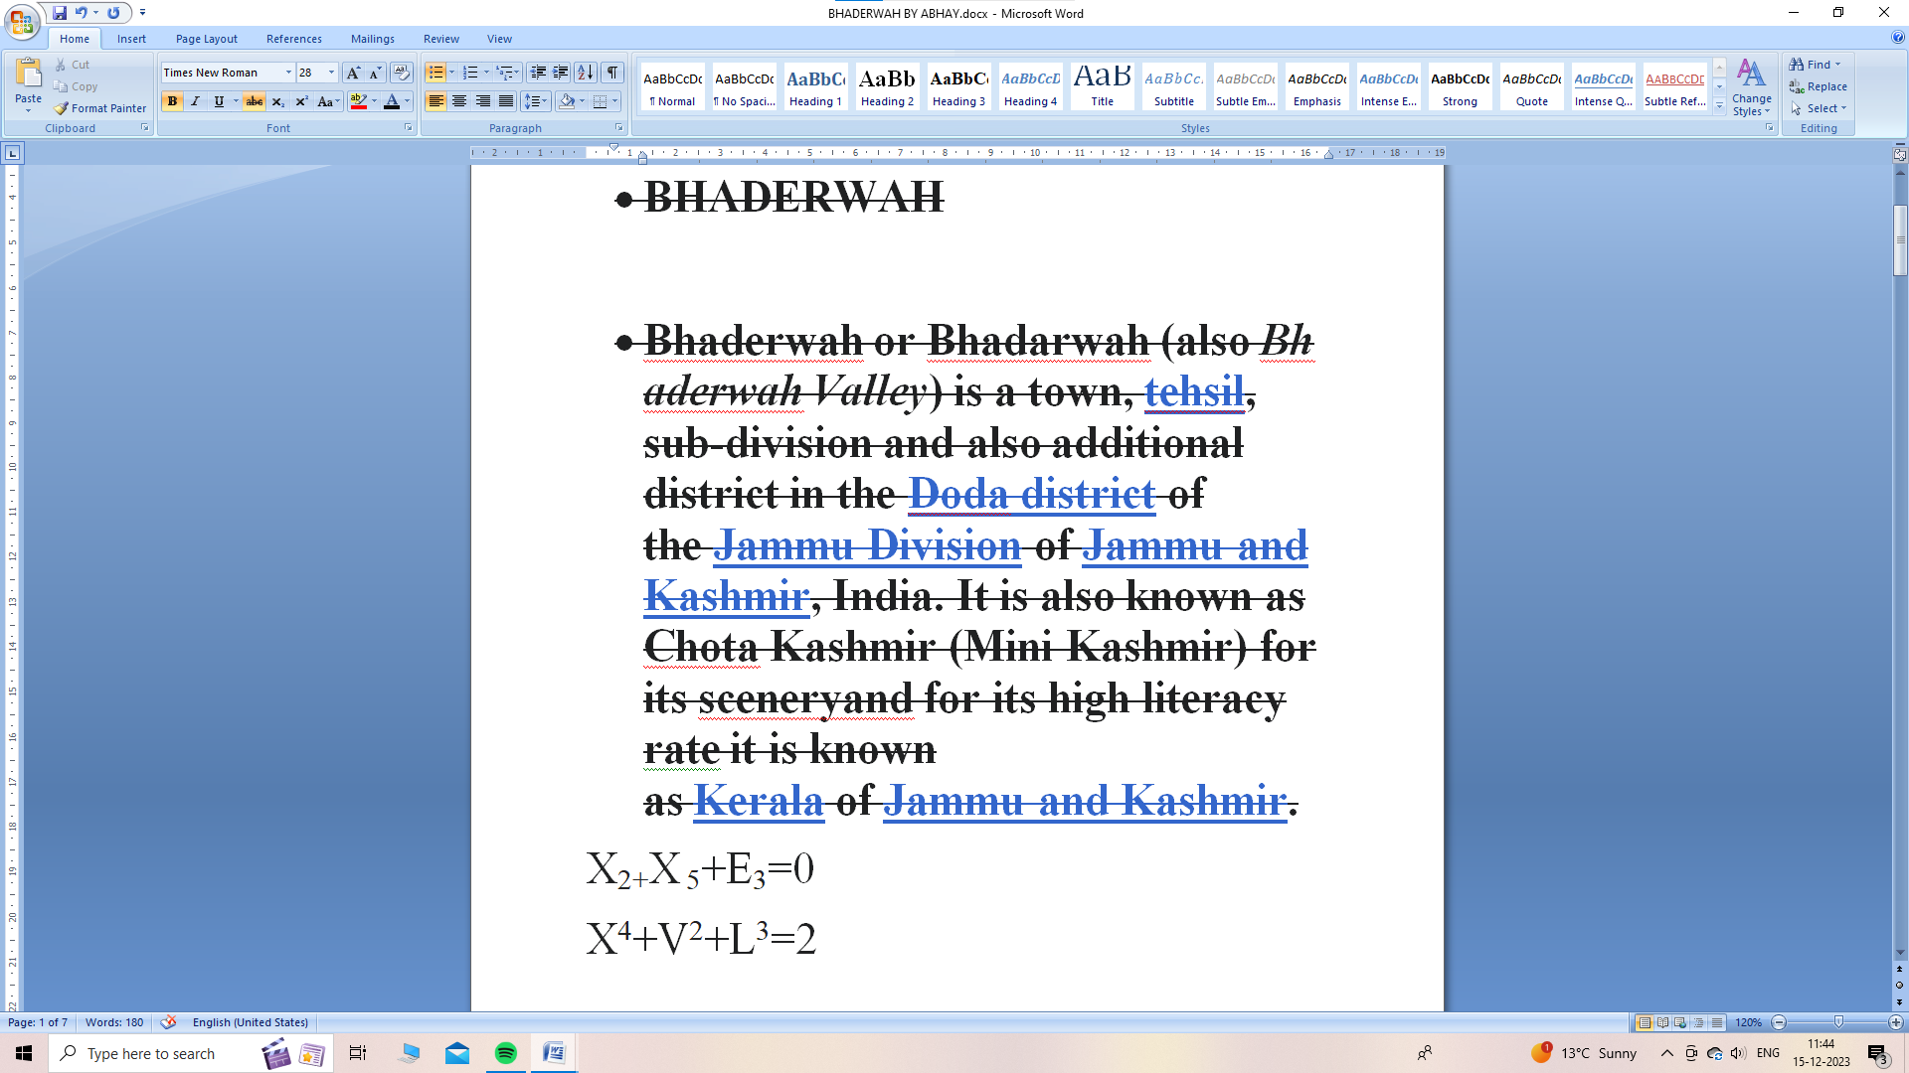

- Using the insert break option .Insert a break page in your document .Insert page number at the bottom of the page using page number option. Insert a table like. Draw the border of the table using draw table option .Select the last row of the table and delete the entire row. Insert some more column to the right in the table.

ROLL NO | NAME | COURCE | LANGUAGE
1 | Atif Bashir | BCA | C
2 | Shadab iqbal | BCA | C

- Insert a picture in a file .Place the picture into the center of the page. Add a thick red border around the picture. Crop the picture 0.5 inches from the left change the size of the picture by pressing right click of the mouse on the picture. Insert caption to the picture.

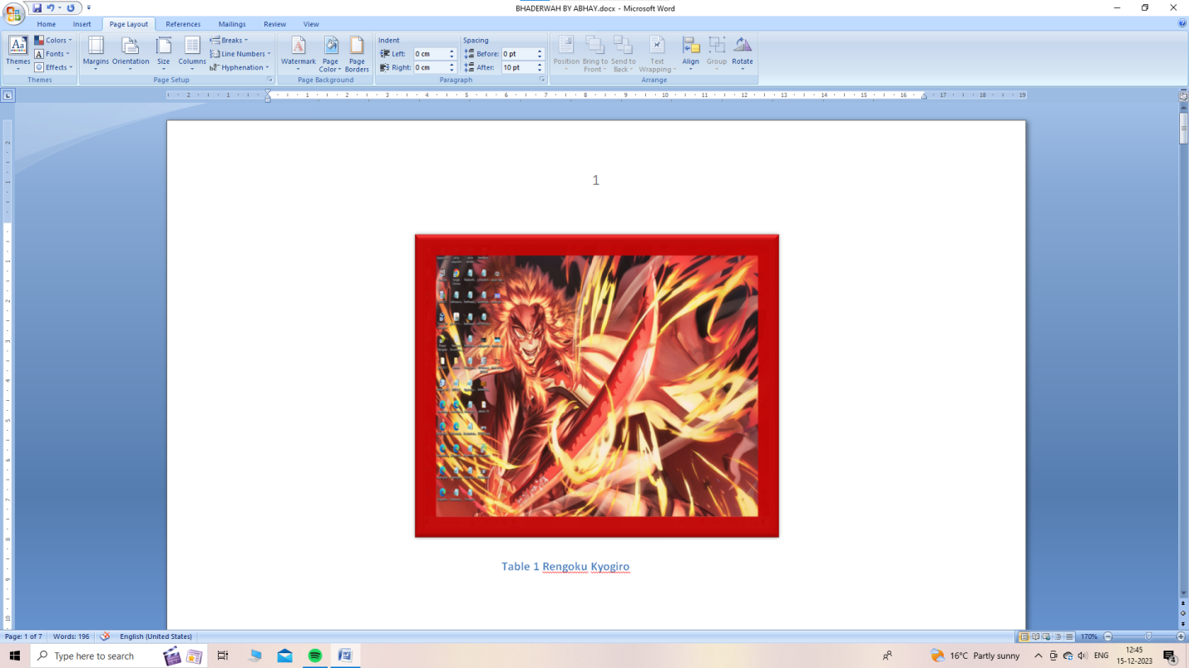

4. Insert header and footer using the header and footer option. Draw a text box and insert the following text. Insert excel worksheet using object option in insert manue. Create a hyperlink and attach a file to the hyper link . Insert bookmark using book mark option.

S.No. | Excel Sheet (Hyperlink)
1 | ..\Salary.xlsx

5. Make the word at the water mark of the document. Select the background colour of the document as red using page colour option . Change the border of the page using page option. Choose the indents tab. Change the spacing between paragraphs by adding spaces above the paragraph.

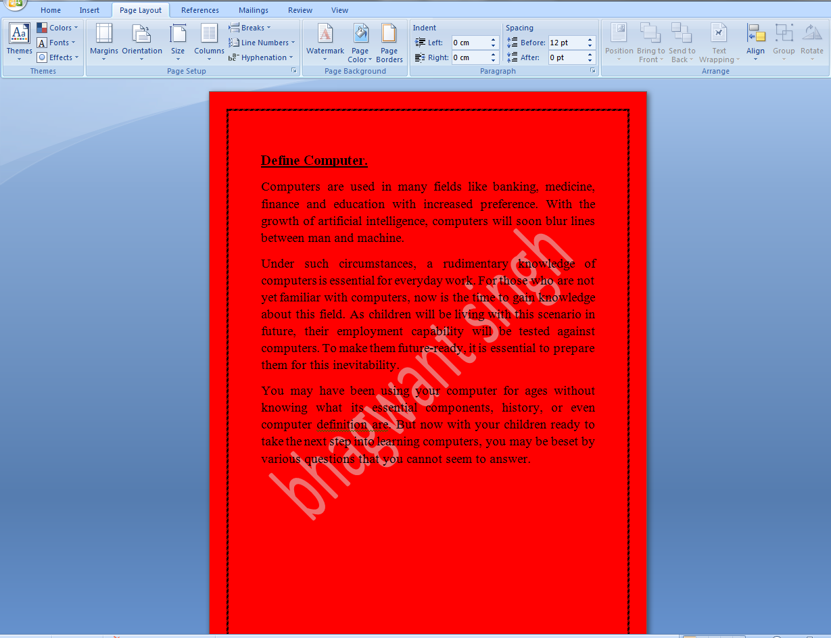

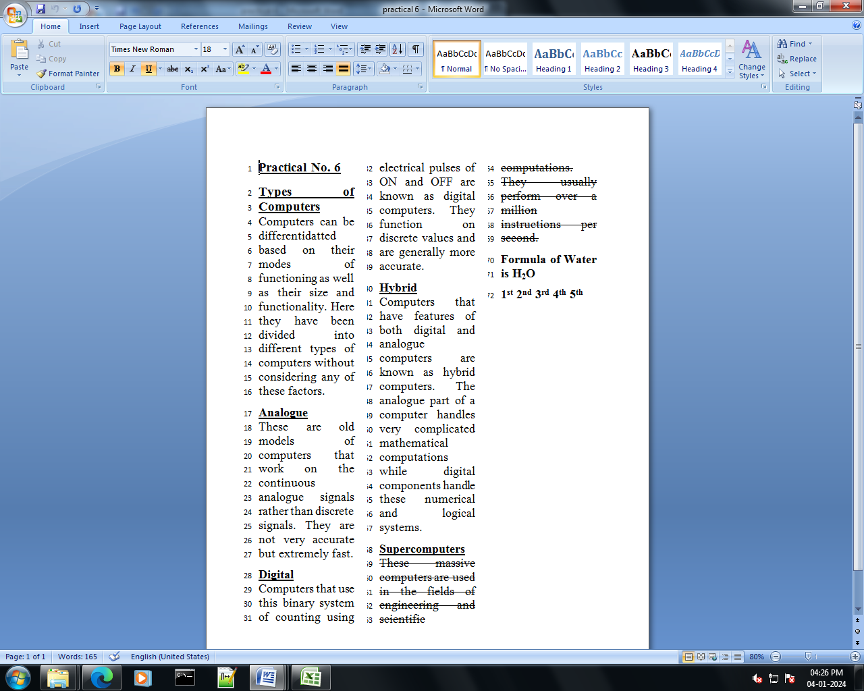
6. Type this paragraph and check the spelling & grammar tool view the doct in full screen using drft tool .View the screen in full made and zoom made add allot of doct.

7.Choose a paper size for the document using size option. Split the text in three columns by using column options. Type the following line and give numbers to that line using line number option.
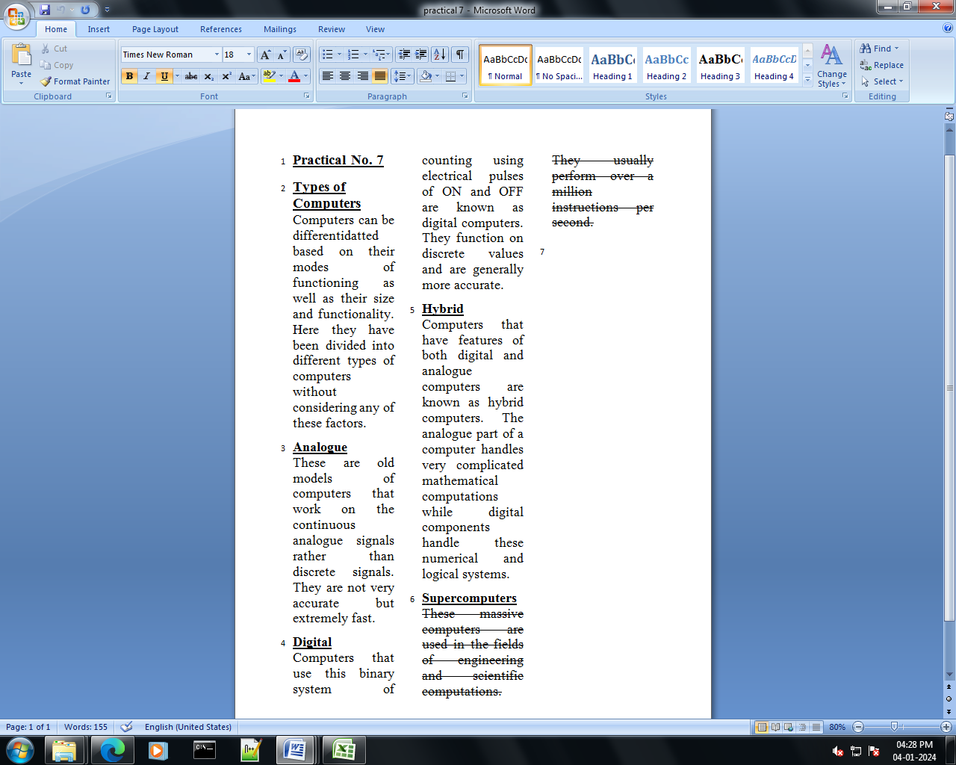

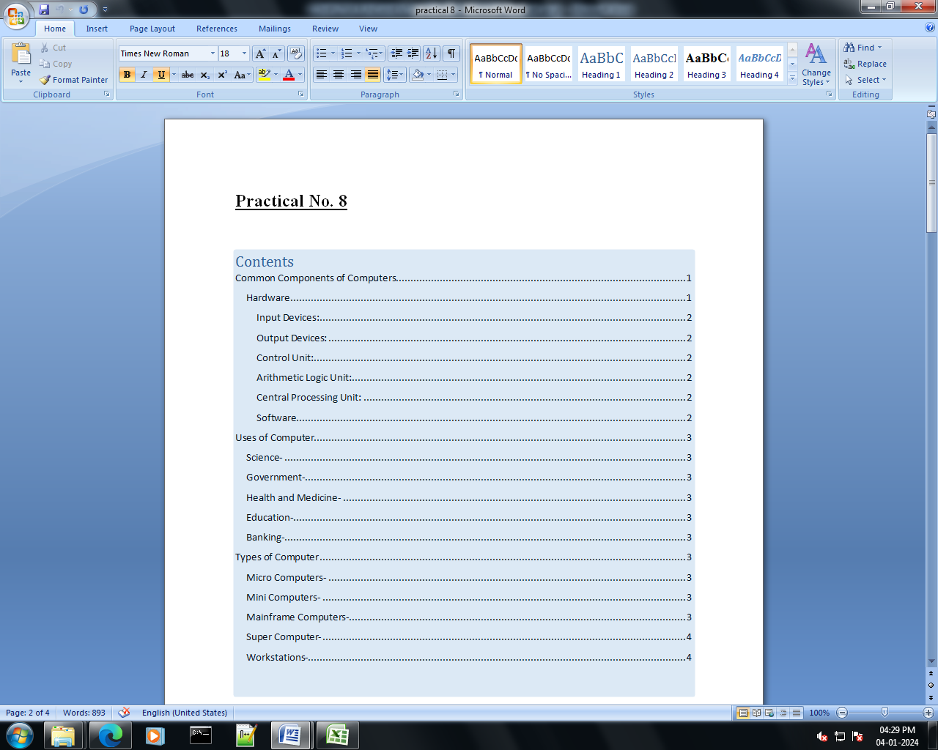
8.Add a table of content to the document Update the Table of content insert foot note to the document insert an end note to the document insert an index into the document create labels to the document

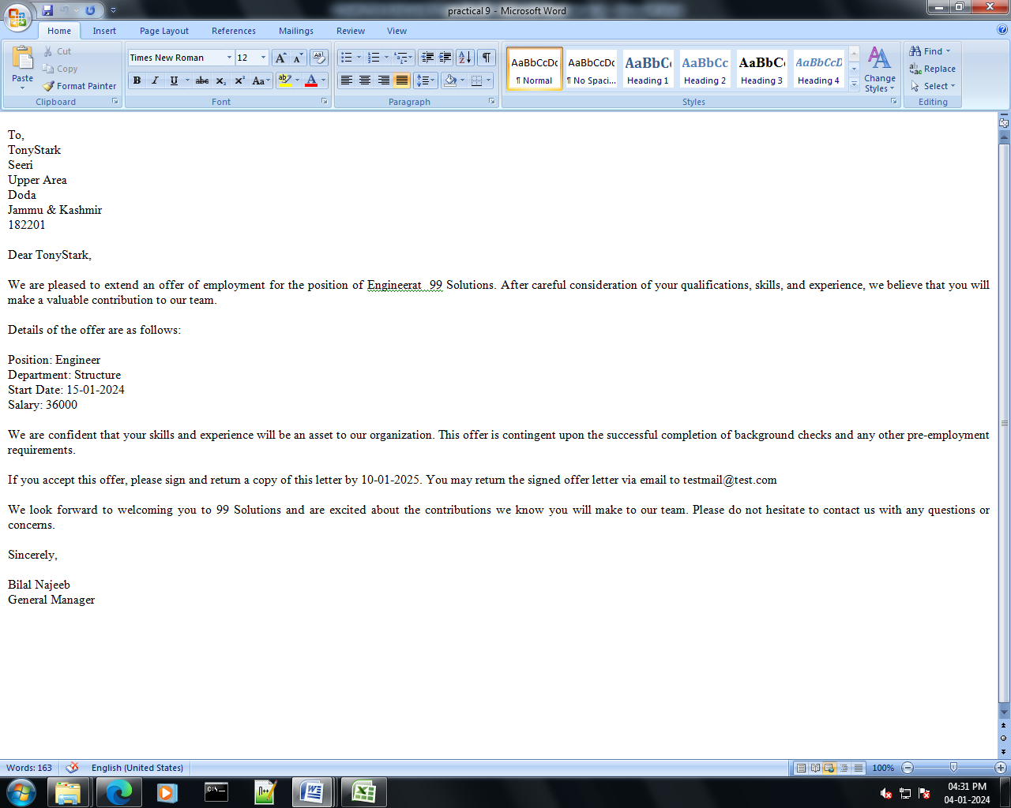
9.Use mail merge to send an official initiation to the employs of the Company to attend a workshop.

10. Create a macro to insert a formatted table with previously defined rows and columns and with appropriate headings.
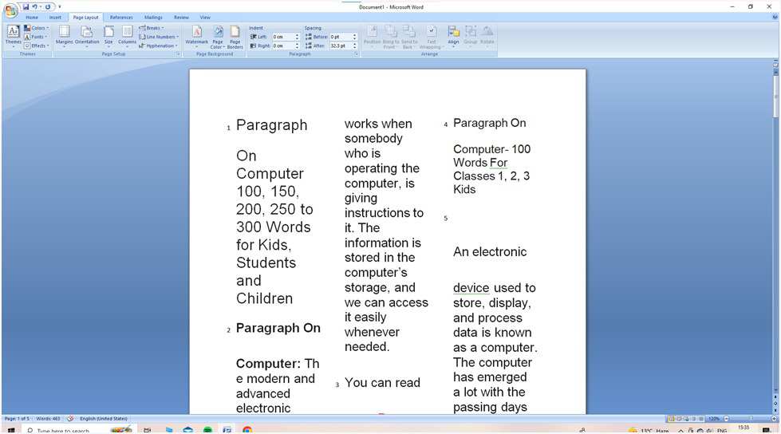

11. Perform arithmetics on five sets of two number
Number 1 Number 2 Add Sub Mul Div.

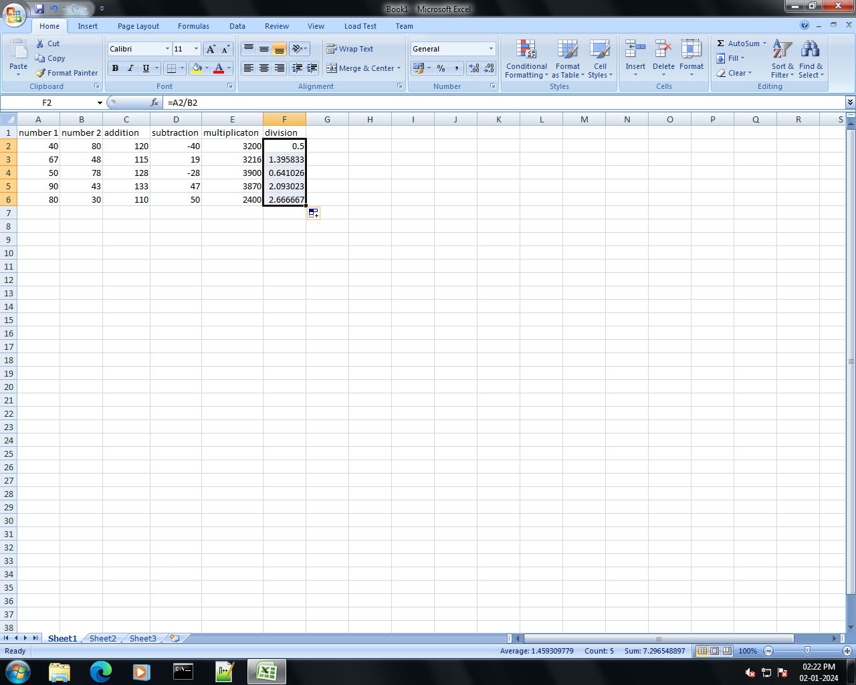

12. Consider the problem of a stationery order for month of march. The description ,quantity and cost per item if to be calculated & the final cost per item involve a add tax of two percent over the total cost .The graph total & net total are to be displayed.
Description Quantity Cost per item.

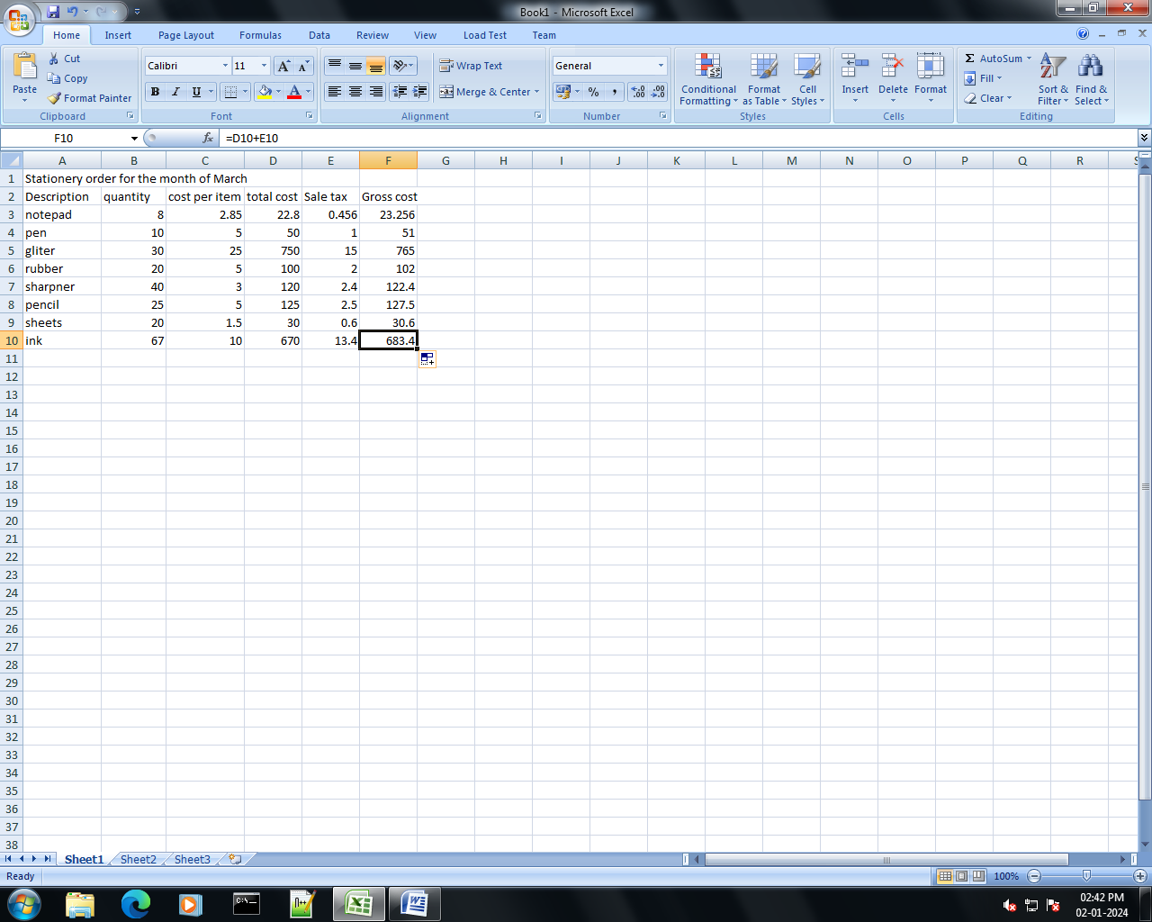

13.let us consider problem of finding the total and average of two subject marks for five students in a class in board exam.

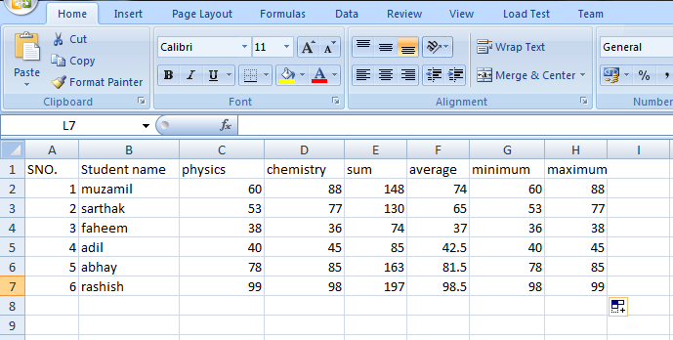

14. In a problem you are given the name ,gender ,attendance assignment , mid term and find grade of five students. Find the total of the assignment marks students who pass need to have a total score greater then or equal to 50 display the word pass or fail under a column called description

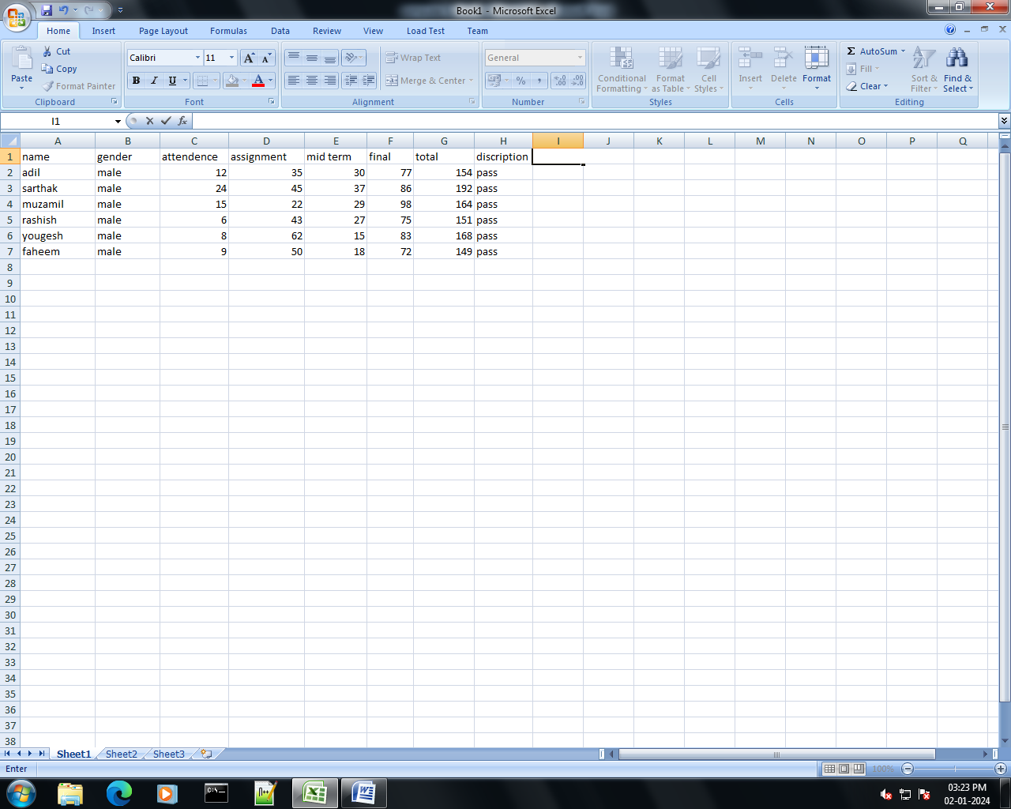

15. You are given a file containing the name and age of people . You have to count no of people in each category as minor major 18-25. Middle agw 26-40,above middle age 40-60, & senior citizen 61-100. Using the single function ,for each scenario & create the font pertaining to the condition.

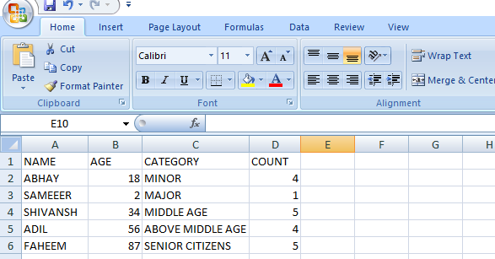

16. Consider a table containg the consuments of different fruits from different suppliers as show below.
Product Supplier Quantity
Cherries ____ _______
Bananas ____ _______
Apples ____ _______
Oranges ____ _______

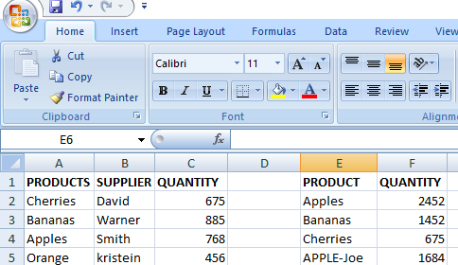

17.Calculate the first name ,last name,email id of the full name of the employee.

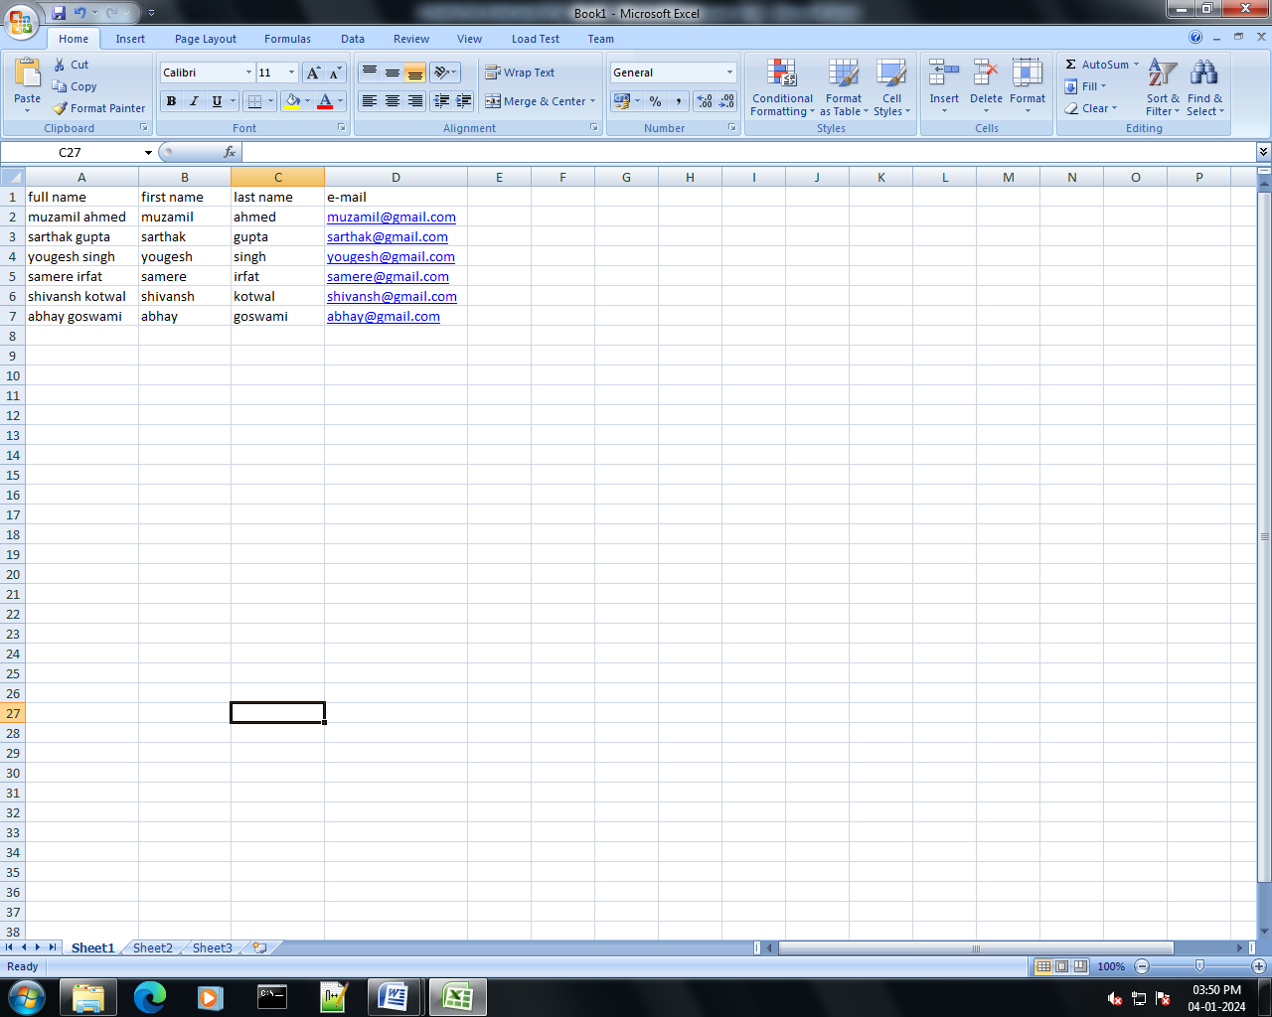

18. Use Vlookup to search name of employee by their customee ID

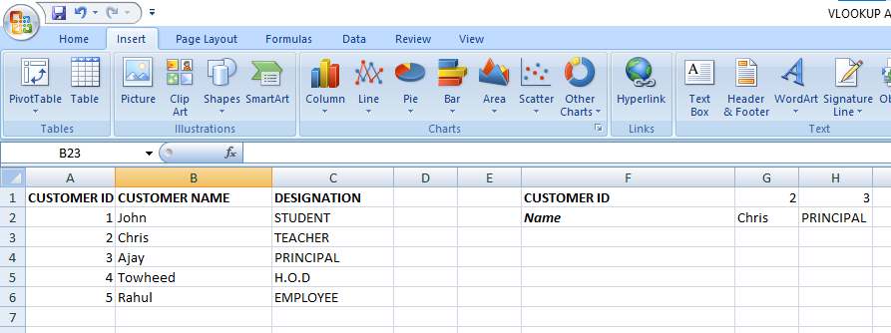

19. Use V-lookup to extract the info from multiple tables .

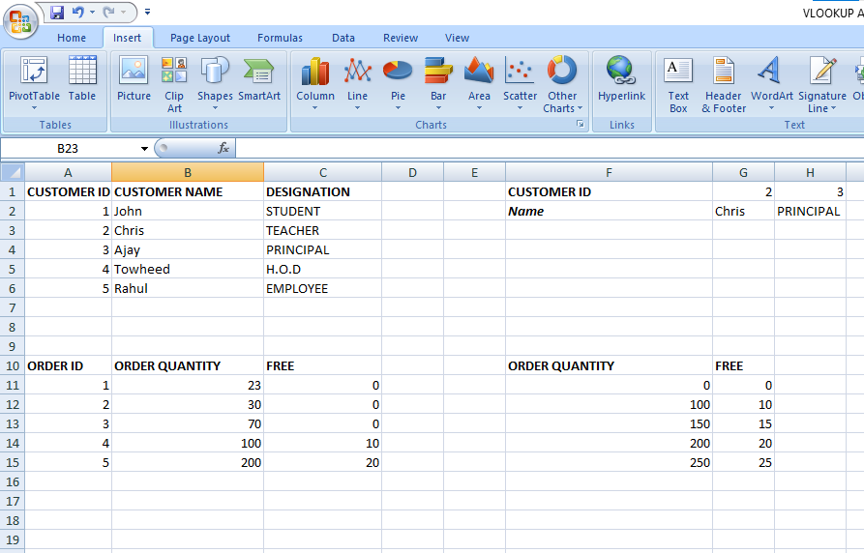

20. Use H- look upto search the name of employee by their customer id.
